### 10.9. Department Comparison Dashboard

#### 10.9.1. Use Case Description

This dashboard shall enable the users (senior management and HR) to see the comparison of data on various parameters ( recognition trend, employee to manager ratio, PIP count & Rating distribution, risk distribution, count of polls, productivity, attrition) across the departments for the time period selected.

#### 10.9.2. Business Rules

* **Recognition Trend** – System shall allow the user to visualize trend of number of employees in the departments who have bagged organization wide Recognitions in the Digital Workspace for the selected period of time.

Line Chart: For X – Axis : Time period, Y – Axis : Count of employees in various departments

* **Employee to Manager Ratio** - System shall allow the user to visualize ratio of ‘number of employees’ to ‘number of managers’ in each department within the organization

Bar Chart: For X- Axis: Departments, Y – Axis : Count (Employee to Manager Ratio)

* **PIP Count and Rating Distribution** - On Clicking the PIP button, Bar chart will be displayed. On clicking Rating button, Line chart will be displayed.

**PIP Count distribution** – Displays count of PIP employee distribution across the departments.

Bar Chart: X – Axis: Departments, Y – Axis: PIP count of the employees in the department.

**Rating distribution** – Displays rating distribution across the departments (to see how each departments Rating Curve looks like)

Line Chart :  X- Axis will have rage of ratings or scores of bin ( Ex: 0 to 1, 1 to 2, 2 to 3 , 3 to 4 , 4 to 5 ), Y-Axis will have count of employees in the department with the ratings achieved

* **Risk Distribution** - Stacked Bar Chart with 3 values - Will show Low Risk, Medium Risk, High Risk across the departments being compared.

Bar Chart: X- Axis : Risk count, Y-Axis : Departments wise ( High, Med, Low)

This chart has 2 levels of drill down

On Click of any bar – 1st level drill down to show the High Risk Distribution - it will show a pie chart with % of risk split between ‘Polls based risk’ and ‘Events based risk’ -

On click of Polls Or Events on Pie Chart – it will show a Bar chart with top 5 category’s of Risk whether Polls Related Categories or Event Logs related categories

* **Count Of Polls** : It shows a comparision of various departments based on the number of Polls held - whether its ‘System driven Polls’ and ‘ Manager Driven Polls’. Basically it shows how many manager driven polls are conducted in each department showing the involvement of Managers

Stacked Bar Chart : X- Axis : Departments, Y-Axis : Count ( split between count of System Driven Polls and count of Manager Driven Polls )

[KS] In the absence of leaves calculation of Productivity will not be authentic. So lets call this widget ‘Employee Utilization’ :

* **Department Productivity** – Tree Map to show comparision of Utilization % of employees for Departments ~~Productivity~~ in the organization. ~~To arrive at Productivity % – total number of employees and number of total utilization days and divide by hours (as per their configuration of work hours per day by Admin).~~

‘Employee Utilization’ - for selected period of time  - count of employee where task count is equal to or greater than one / total count of employees

* **New Hire / Attrition**  – This is a clustered Bar Chart which shows ‘No. of New Hires’ v/s ‘No. of Exits’ for each department of the organization

This has 2 levels of Drill down :

1st level Drill down will show – split of New Hires and Exits counts based on their role. Like how many Managers Hired and how many Exited.

2nd level drill down is a report to show the data in a tabular format – The Name / Title / ‘Date Of Hire’ or ‘Date of Exit’ of the employees who have been hired or have exited the Dept.

#### 10.9.3. Screenshot of Proposed Layout (To Be Updated)

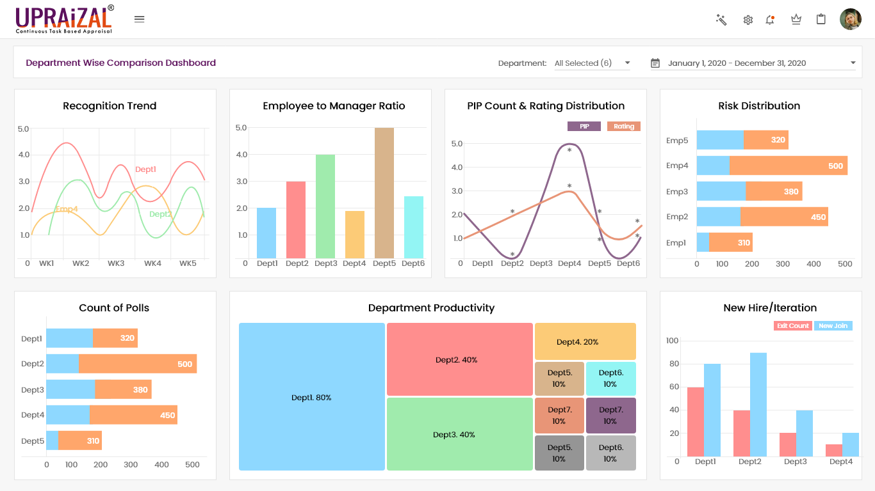

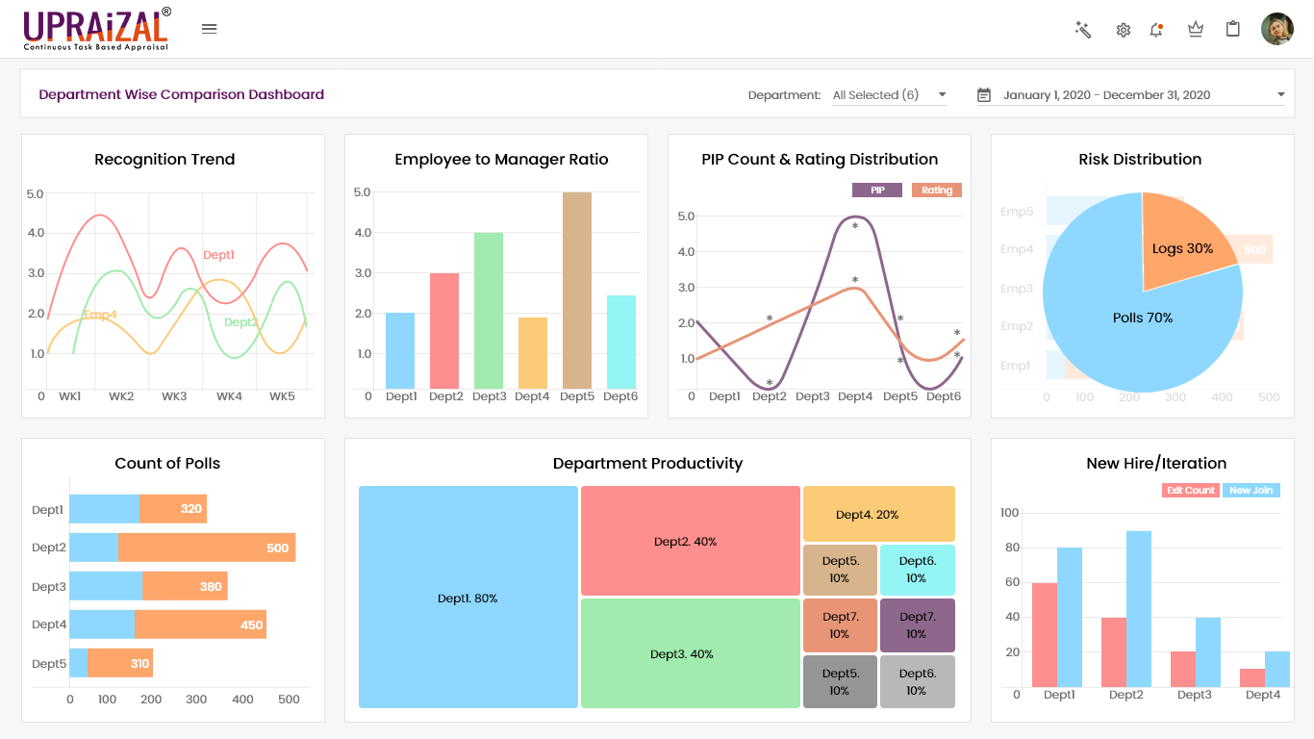

#### 10.9.4. UI Elements

|  |  |
| --- | --- |
| Field Name | Description |
| Current Year vs Previous Year | For selecting the data comparison of the current year and previous year, current month, last 30 days or customized date range |
| Department Selection | Departments dropdown for Multi selection |